=========================================================================
Name : Sneha Bandi
Roll No : 2401
Title : DDA-Bresenham line drawing algorithm
=========================================================================

------------------------------------------→>> line.h << ----------------------------------------------------------

#ifndef LINE_H
#define LINE_H
#include <QMainWindow>
#include<QImage>
#include<QPixmap>
namespace Ui {
class line;
}
class line : public QMainWindow
{
Q_OBJECT
public:
explicit line(QWidget *parent = 0);
~line();
private:
Ui::line *ui;
int x1,x2,y1,y2;
private slots:
void accept_dda(); //to accept the co ordinates
void display(int,int); //DDA
void accept_bresen();
void display(int,int,int);//bresenhams
int sign(int);
void clear();
};
#endif // LINE_H
------------------------------------------→>> line.cpp << ----------------------------------------------------------
#include "line.h"
#include "ui_line.h"
#include<QtGui>
line::line(QWidget *parent) :
QMainWindow(parent),
ui(new Ui::line)
{
ui->setupUi(this);
connect(this->ui->pushButton,SIGNAL(clicked()),this,SLOT(accept_dda()));
connect(this->ui->pushButton_2,SIGNAL(clicked()),this,SLOT(accept_bresen()));
connect(this->ui->pushButton_3,SIGNAL(clicked()),this,SLOT(clear()));
}
line::~line()
{
delete ui;
}
void line::accept_dda()
{
x1=ui->textEdit->toPlainText().toInt();
y1=ui->textEdit_2->toPlainText().toInt();
x2=ui->textEdit_3->toPlainText().toInt();
y2=ui->textEdit_4->toPlainText().toInt();
int dx,dy;
dx=x2-x1;
dy=y2-y1;
display(dx,dy);
}
void line::display(int dx, int dy)
{
QImage img(291,231,QImage::Format_ARGB32);
QRgb rgb=qRgb(255,255,255);
img.fill(QColor(Qt::black).rgb());
int n;
float x_1,y_1;
float x,y;
if(dx>=dy)
n=dx;
else
n=dy;
x_1=(float)dx/n;
y_1=(float)dy/n;
x=x1;
y=y1;
img.setPixel(x1,y1,rgb);
ui->label_5->setPixmap(QBitmap::fromImage(img));
for(int i=0;i<n;i++)
{
x=x+x_1;
y=y+y_1;
img.setPixel(x,y,rgb);
ui->label_5->setPixmap(QBitmap::fromImage(img));
}
}
int line::sign(int x)
{
if(x<0)
return -1;
else if(x>0)
return 1;
else
return 0;
}
void line::accept_bresen()
{
x1=ui->textEdit->toPlainText().toInt();
y1=ui->textEdit_2->toPlainText().toInt();
x2=ui->textEdit_3->toPlainText().toInt();
y2=ui->textEdit_4->toPlainText().toInt();
int dx,dy;
int interchange;
int temp;
dx=abs(x2-x1);
dy=(y2-y1);
if(dy>dx)
{
temp=dx;
dx=dy;
dy=temp;
interchange=1;
}
else
interchange=0;
display(dx,dy,interchange);
}
void line::display(int dx, int dy, int interchange)
{
QImage img(291,231,QImage::Format_ARGB32);
QRgb rgb=qRgb(255,255,255);
img.fill(QColor(Qt::black).rgb());
int ebar;
int i;
float x,y;
int s1,s2;
x=x1;
y=y1;
s1=sign(x2-x1);
s2=sign(y2-y1);
ebar=2*dy-dx;
for(i=1;i<=dx;i++)
{
img.setPixel(x,y,rgb);
ui->label_6->setPixmap(QBitmap::fromImage(img));
while(ebar>0)
{
if(interchange==1)
x=x+s1;
else
y=y+s2;
ebar=ebar-2*dx;
}
if(interchange==1)
y=y+s2;
else
x=x+s1;
ebar=ebar+2*dy;
}
}
void line::clear()
{
ui->textEdit->clear();
ui->textEdit_2->clear();
ui->textEdit_3->clear();
ui->textEdit_4->clear();
ui->label_5->clear();
ui->label_6->clear();
}

------------------------------------------→>> OUTPUT << ----------------------------------------------------------
A.) POSITIVE SLOPE m=1

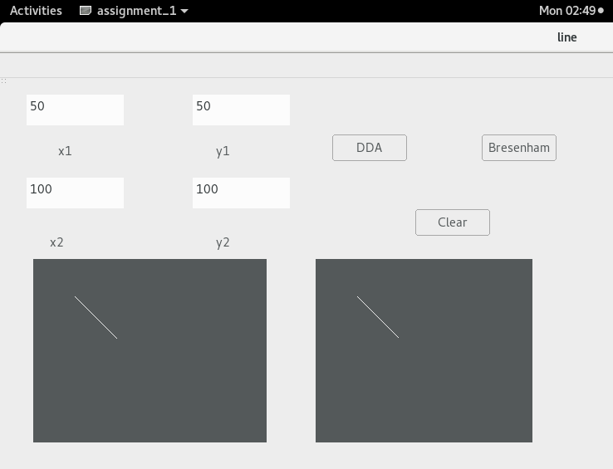
b.) NEGATIVE SLOPE m=-1
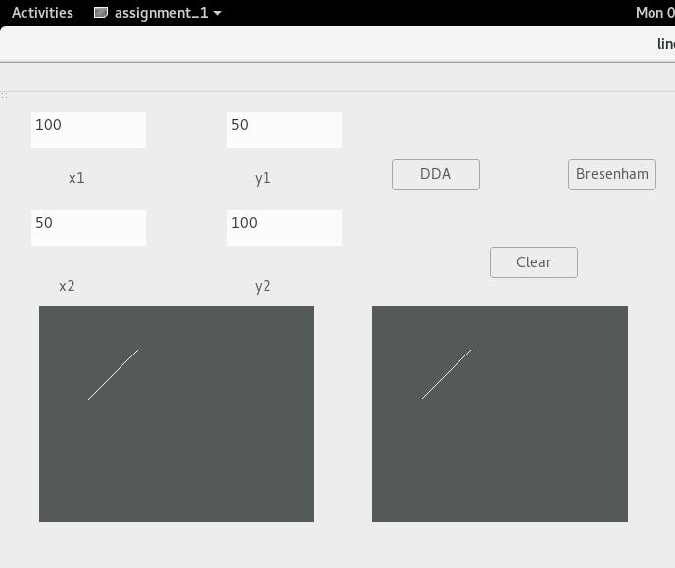

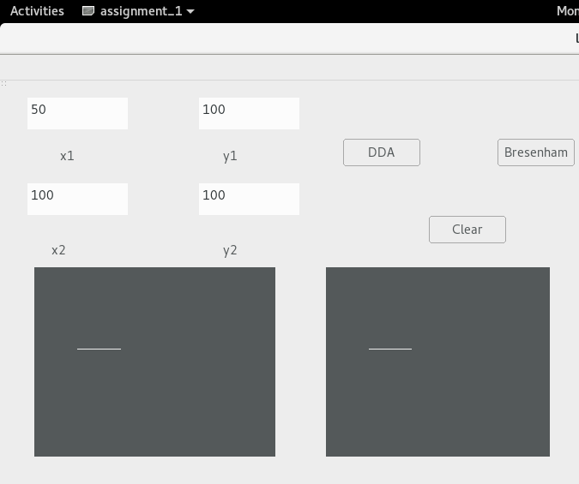
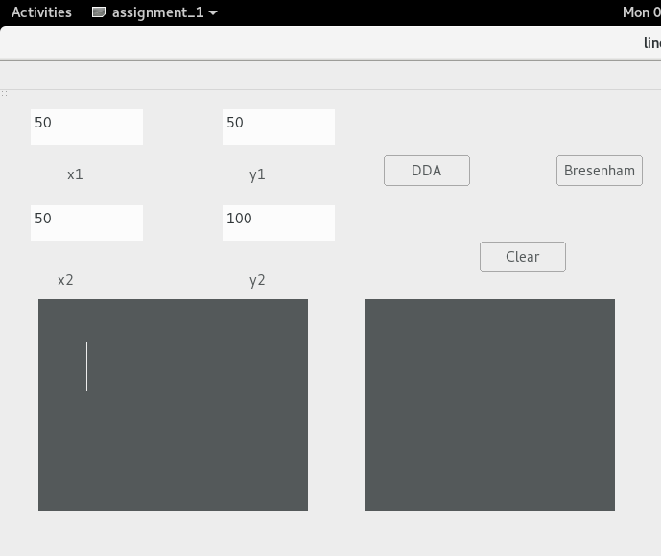
C.) INFINITY SLOPE

D.) ZERO SLOPE

